EMCH 260 HW #4 JACOB VAUGHT
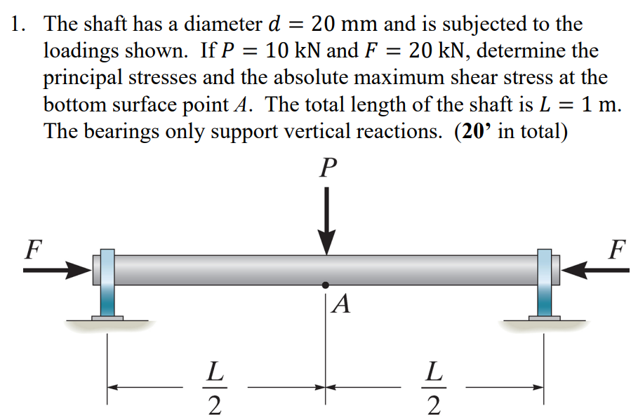
$$d=0.02m;P=10kN;F=20kN;L=1 m$$
$$A=\frac{π}{4}*d^{2}=\frac{π}{4}*{0.02}^{2}=\frac{π}{10000}$$
$$Mc=\frac{1000*1}{4}=2500$$
$$I=\frac{π}{64}d^{4}=\frac{π}{64}*{0.02}^{4}=\frac{π}{400000000}$$
$$σ_{x}=\frac{N}{A}+\frac{Mc*x}{I}→\frac{-20000}{\frac{π}{10000}}+\frac{2500*0.01}{\frac{π}{400000000}}=\frac{9800000000}{π}Pa≅3.11GPa$$
$$σy=0, τxy=0$$
$$τmax=\sqrt{{\left(\frac{σx-σy}{2}\right)}^{2}+τxy^{2}}=\sqrt{{\left(\frac{\frac{9800000000}{π}-0}{2}\right)}^{2}+0^{2}}=\frac{4900000000}{π}≅1.56GPa$$

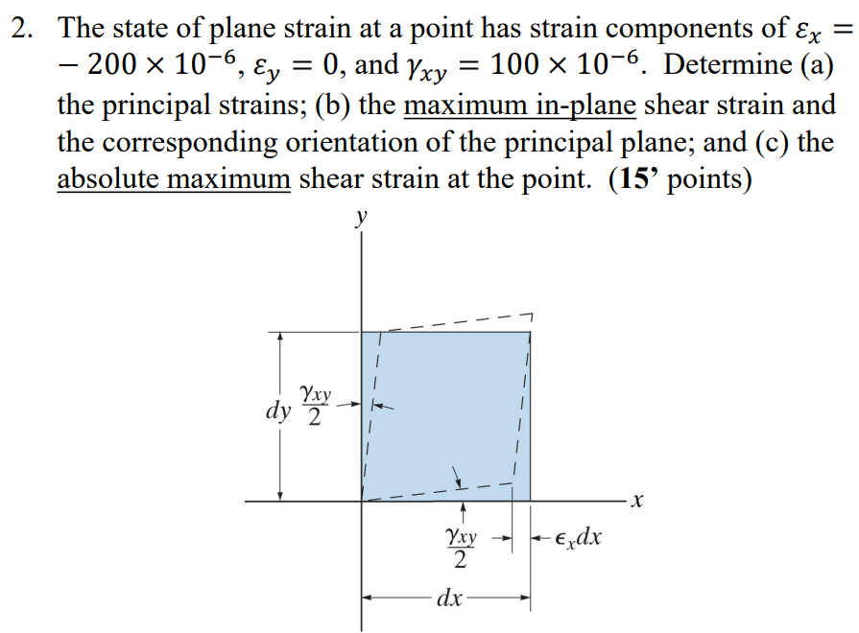
$$C=\frac{εx+εy}{2}=\frac{-200*{10}^{-6}+0}{2}=\left(-100*{10}^{-6},0\right)$$
$$R=\sqrt{{\left(\frac{εx-εy}{2}\right)}^{2}+{\left(\frac{yxy}{2}\right)}^{2} }={\sqrt{\left({\left(εx^{'}-εavg\right)}^{2}+{\left(\frac{Yx^{'}y^{'}}{2}\right)}^{2}\right)} }^{}=\sqrt{\left({\left(\frac{-200-0}{2}\right)}^{2}+{\left(\frac{100}{2}\right)}^{2}\right)}*{10}^{-6}=50\sqrt{5}*{10}^{-6}$$
$$ε1,2=\frac{εx+εy}{2}±\sqrt{{\left(\frac{εx-εy}{2}\right)}^{2}+{\left(\frac{yxy}{2}\right)}^{2}}$$
$$ε1=\frac{εx+εy}{2}+\sqrt{{\left(\frac{εx-εy}{2}\right)}^{2}+{\left(\frac{yxy}{2}\right)}^{2}}=\frac{-200}{2}+\sqrt{{\left(\frac{-200}{2}\right)}^{2}+{\left(100\right)}^{2}}=\left(-100+50\sqrt{5}\right)*{10}^{-6}≅11.8*{10}^{-6}$$
$$ε2=\frac{εx+εy}{2}-\sqrt{{\left(\frac{εx-εy}{2}\right)}^{2}+{\left(\frac{yxy}{2}\right)}^{2}}=\frac{-200}{2}-\sqrt{{\left(\frac{-200}{2}\right)}^{2}+{\left(\frac{100}{2}\right)}^{2}}=\left(-100-50\sqrt{5}\right)*{10}^{-6}≅-211.8*{10}^{-6}$$
$$y\left(\begin{aligned}in \\ plane max\end{aligned}\right)=ε1-ε2=\left(-100+50\sqrt{5}\right)-\left(-100-50\sqrt{5}\right)=100\sqrt{5}*{10}^{-6}≅223.6*{10}^{-6}$$
$$2θp1=180°-\tan^{-1}\left(\frac{Yxy}{εx-εy}\right)=180°-\tan^{-1}\left(\frac{100}{200}\right)=153.435°→θp1=76.72°$$
$$γ(abs max)=ε1-ε2=\left(-100+50\sqrt{5}\right)-\left(-100-50\sqrt{5}\right)=100\sqrt{5}*{10}^{-6}≅223.6*{10}^{-6}$$

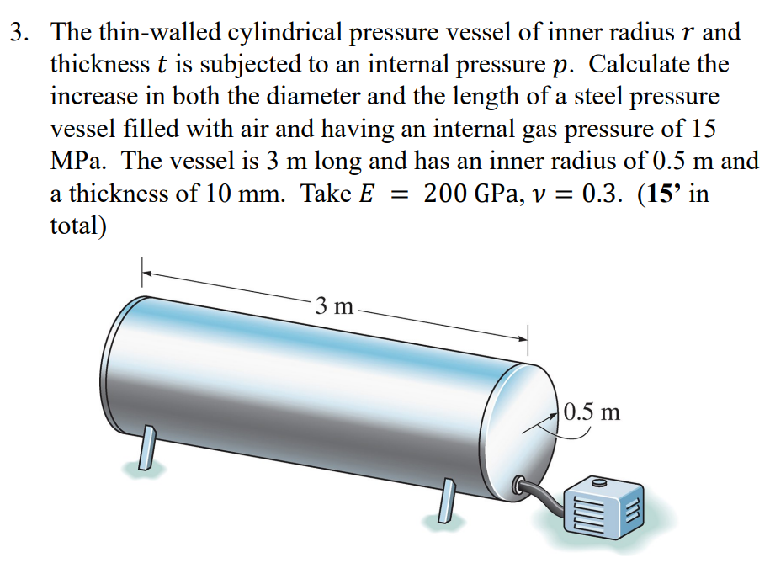
$$σ_{x}=σ_{hoop}=\frac{p*r}{t}=\frac{15*{10}^{6}Pa*0.5m}{0.01m}=750MPa$$
$$σ_{y}=σ_{longitudinal}=\frac{p*r}{2t}=\frac{15*{10}^{6}Pa*0.5m}{2*0.01m}=375MPa$$
$$σ_{z}=0$$
$$ε_{cir}=\frac{1}{E}\left(σ_{x}-υ\left(σ_{y}+σ_{z}\right)\right)=\frac{1}{200*{10}^{9}}\left(750*{10}^{6}Pa-0.3*\left(375*{10}^{6}Pa\right)\right)=0.0031875$$
$$ε_{long}=\frac{1}{E}\left(σ_{y}-υ\left(σ_{x}+σ_{z}\right)\right)=\frac{1}{200*{10}^{9}}\left(375*{10}^{6}Pa-0.3*\left(750*{10}^{6}Pa\right)\right)=0.00075$$
$$Δd=ε_{cir}*d=0.0031875*2*0.5m=3.1875mm$$
$$ΔL=ε_{long}*L=0.00075*3m=2.25 mm$$

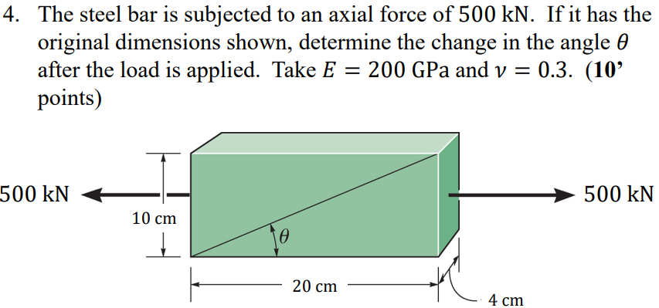
$$A=0.04*0.1=0.004m^{2}$$
$$σx=\frac{Fx}{A}=\frac{500kN}{0.004m^{2}}=125 MPa$$
$$σy=0;$$
$$σz=0;$$
$$εx=\frac{σx}{E}-\frac{υ}{E}\left(σy+σz\right)=\frac{125*{10}^{6}}{200*{10}^{9}}=0.000625$$
$$ΔL=L*εx=0.2m*0.000625=0.000125$$
$$εy=\frac{σy}{E}-\frac{υ}{E}\left(σx+σz\right)=-\frac{0.3}{200*{10}^{9}}\left(125*{10}^{6}\right)=-0.0001875m$$
$$Δh=h*εy=0.1m*-0.0001875=-0.00001875m$$
$$θ=\tan^{-1}\left(\frac{1}{2}\right)=26.56°$$
$$θ^{'}=\tan^{-1}\left(\frac{0.1-0.00001875}{0.2+0.000125}\right)=26.54°$$
$$change in θ=\tan^{-1}\left(\frac{1}{2}\right)-\tan^{-1}\left(\frac{0.1-0.00001875}{0.2+0.000125}\right)=0.0186°$$

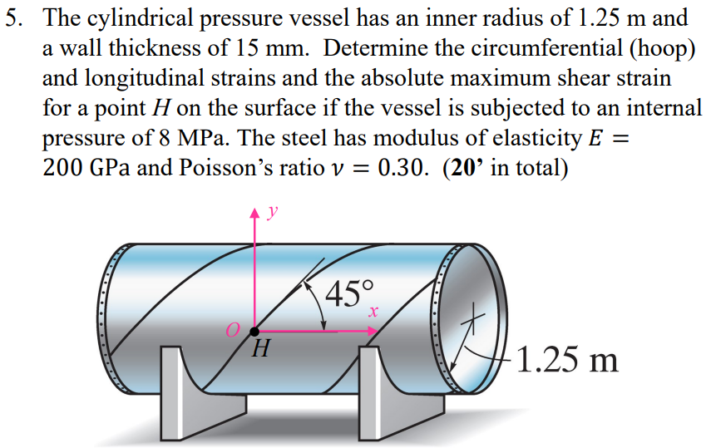
$$σ_{x}=σ_{hoop}=\frac{p*r}{t}=\frac{8*{10}^{6}Pa*1.25m}{0.015m}=\frac{\left(2*{10}^{9}\right)}{3}Pa$$
$$σ_{y}=σ_{longitudinal}=\frac{p*r}{2t}=\frac{8*{10}^{6}Pa*1.25m}{2*0.015m}=\frac{\left(1*{10}^{9}\right)}{3}Pa$$
$$σ_{z}=0$$
$$ε_{cir}=ε_{y}=\frac{1}{E}\left(σ_{x}-υ\left(σ_{y}+σ_{z}\right)\right)=\frac{1}{200*{10}^{9}}\left(\frac{\left(2*{10}^{9}\right)}{3}-0.3*\left(\frac{\left(1*{10}^{9}\right)}{3}\right)\right)=\frac{17}{6000}m/m≅ 0.00283$$
$$ε_{long}=ε_{x}=\frac{1}{E}\left(σ_{y}-υ\left(σ_{x}+σ_{z}\right)\right)=\frac{1}{200*{10}^{9}}\left(\frac{\left(1*{10}^{9}\right)}{3}-0.3*\left(\frac{\left(2*{10}^{9}\right)}{3}\right)\right)=\frac{1}{1500}m/m≅ 0.000666$$
$$τ_{\begin{matrix}abs \\ max\end{matrix}}=\frac{σx}{2}=\frac{\left(1*{10}^{9}\right)}{3}Pa$$
$$G=\frac{E}{2\left(1+υ\right)}=\frac{200*{10}^{9}}{2*(1+0.3)}=\frac{{10}^{12}}{13}$$
$$γ_{\begin{matrix}abs \\ max\end{matrix}}=\frac{τ_{\begin{matrix}abs \\ max\end{matrix}}}{G} =\frac{\left(\frac{\left(1*{10}^{9}\right)}{3}\right)}{\left(\frac{{10}^{12}}{13}\right)}=\frac{13}{3000}≅0.004333rad$$
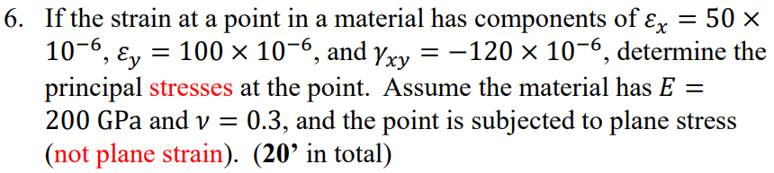
$$ε_{y}=\frac{1}{E}\left(σ_{x}-υ\left(σ_{y}\right)\right)→100*{10}^{-6}=\frac{1}{200*{10}^{9}}\left(σ_{x}-0.3*\left(σ_{y}\right)\right)$$
$$ε_{x}=\frac{1}{E}\left(σ_{y}-υ\left(σ_{x}\right)\right)→ 50*{10}^{-6}=\frac{1}{200*{10}^{9}}\left(σ_{y}-0.3*\left(σ_{x}\right)\right)$$
$$σ_{x}=\frac{2.3*{10}^{9}}{91}Pa=25.3MPa$$
$σ_{y}=\frac{1.6*{10}^{9}}{91}Pa=17.6MPa$ May have swapped these, but has no effect on the final answer.
$$τ_{xy}=γ_{xy}*G=\frac{E}{2*\left(1+υ\right)}*γ_{xy}=\frac{200*{10}^{9}}{2*\left(1+0.3\right)}*-120*{10}^{-6}=-\frac{120,000,000}{13}Pa=-9.23MPa$$
$$σ_{1,2}=\frac{σ_{x}+σ_{y}}{2}±\sqrt{{\left(\frac{σ_{x}-σ_{y}}{2}\right)}^{2}+{\left(τ_{xy}\right)}^{2} }$$
$$σ_{1}=\frac{\frac{1.6*{10}^{9}}{91}+\frac{2.3*{10}^{9}}{91}}{2}+\sqrt{{\left(\frac{\frac{2.3*{10}^{9}}{91}-\frac{1.6*{10}^{9}}{91}}{2}\right)}^{2}+{\left(-\frac{120*{10}^{6}}{13}\right)}^{2} }=31.4 MPa$$
$$σ_{2}=\frac{\frac{2.3*{10}^{9}}{91}+\frac{1.6*{10}^{9}}{91}}{2}-\sqrt{{\left(\frac{\frac{2.3*{10}^{9}}{91}-\frac{1.6*{10}^{9}}{91}}{2}\right)}^{2}+{\left(-\frac{120*{10}^{6}}{13}\right)}^{2}}=11.4MPa$$

